4.6.1 Triple Integrals in Cylindrical Coordinates

The cylindrical coordinate system is designed to help us find triple integrals over certain types of regions in three space. The cylindrical coordinate system is the three dimensional equivalent of polar coordinates.
A picture of a point plotted by its cylindrical coordinates is:

To Convert from Cylindrical to Rectangular Coordinates:
Use the following equations: , , and .

To Convert from Rectangular Coordinates to Cylindrical Coordinates:
Use the following equations (assuming ):

Fact: Suppose that E is a region whose projection onto the xy-plane, D, is conveniently described in polar. Specifically, suppose that is continuous and where .

Then, by using what we know about double integrals in polar and triple integrals over type 1 regions, we have:
.

Note: One may modify the definition of cylindrical coordinates so that we view the projection onto the xz-plane or yz-plane as being described in polar. However, in this section we will not be considering such modifications. Therefore, when we set up a triple integral as an iterated integral in cylindrical we will always pick z as the innermost variable of integration and follow the general procedure from section 4.5 (keeping in mind that the projection of the solid onto the xy-plane must be described in polar).

Example 1: Evaluate where .

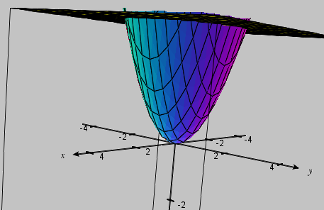
A picture of the solid is shown at the right.

If we want to set up the iterated integral in cylindrical, we first must bound z.
We note that .
Also, the projection of E onto the xy-plane is:
.

So, we have:

Example 2: Use cylindrical coordinates to set up (but do not evaluate) an iterated integral which yields the volume of the solid which lies within the cylinder and the sphere .

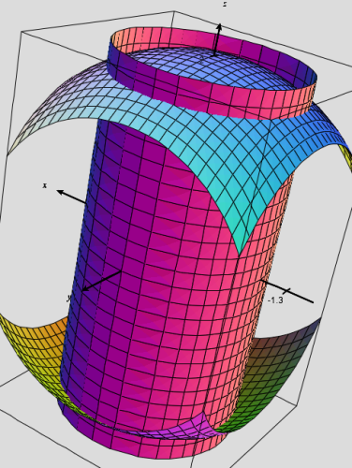
A picture of the solid is shown at the right.

The solid we want the volume of is . We note that . Moreover, the projection of E onto the xy-plane is .
Thus, the volume will be given by: .

Note: It is certainly possible to use symmetry about the xy-plane to solve the above problem.

Example 3: Evaluate the following iterated integral by changing to cylindrical coordinates: .

Note: Usually when students first see a problem like this, it is tempting for them to simply replace all the x variables with and all the y variables with . As we will see this does not quite work in general.

Note is the function integration.
We note that in cylindrical the function of integration becomes:
We also note that the region of integration is .
If we convert the bounds on z to cylindrical, we obtain .

Also, the projection of E onto the xy-plane is: which we recognize as the top half of a circle of radius 3 centered at the origin.
Thus, if we represent D as a polar region (i.e. in cylindrical) it becomes: . So,

Note: This iterated integral would have been very difficult if we stayed in rectangular.

